MOVEMENT SENSED AUTOMATIC DOOR OPENING SYSTEM

ABSTRACT
The project is designed for automatic door opening system using PIR sensor. Opening and closing of doors is always a tedious job, especially in places like shopping malls, hotels and theatres where a person is always required to open the door for visitors.
This project proposes a system of automatic opening and closing of door by sensing any body movement near the door. This is achieved with help of a PIR (Passive Infrared) sensor. A live body generally emits infrared energy which is sensed by the PIR sensor from a considerable distance. This sensing signal is fed to a microcontroller to operate a door motor through motor driver IC. When a body approaches within the operating range of the sensor, it sends a logical command to open the door. The door automatically closes with a fixed time delay. If there is no further movement within the PIR operating range. Interrupt signals are used through limit switches to avoid locked rotor condition of the motor.
Further this project can be enhanced interfacing a counting arrangement for keeping a record of entry and exit of people at particular place. This can be achieved by interfacing the system with an EEPROM (non-volatile memory) to avoid loss of stored data even if the power fails.

BLOCK DIAGRAM
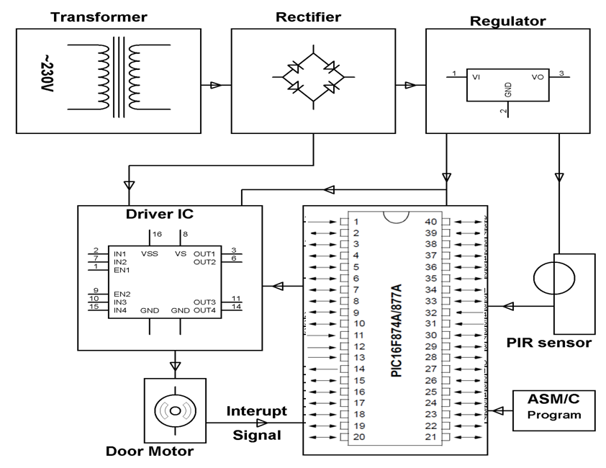

HARDWARE REQUIREMENTS:
PIC series Microcontroller, Transformer, PIR sensor, Motor with sliding door, Motor Driver IC, Diodes, Resistors, Capacitors, Crystal, Transistor.
SOFTWARE REQUIREMENTS
HI-TECH PICC Tool suite
Language: Embedded C Or Assembly.

